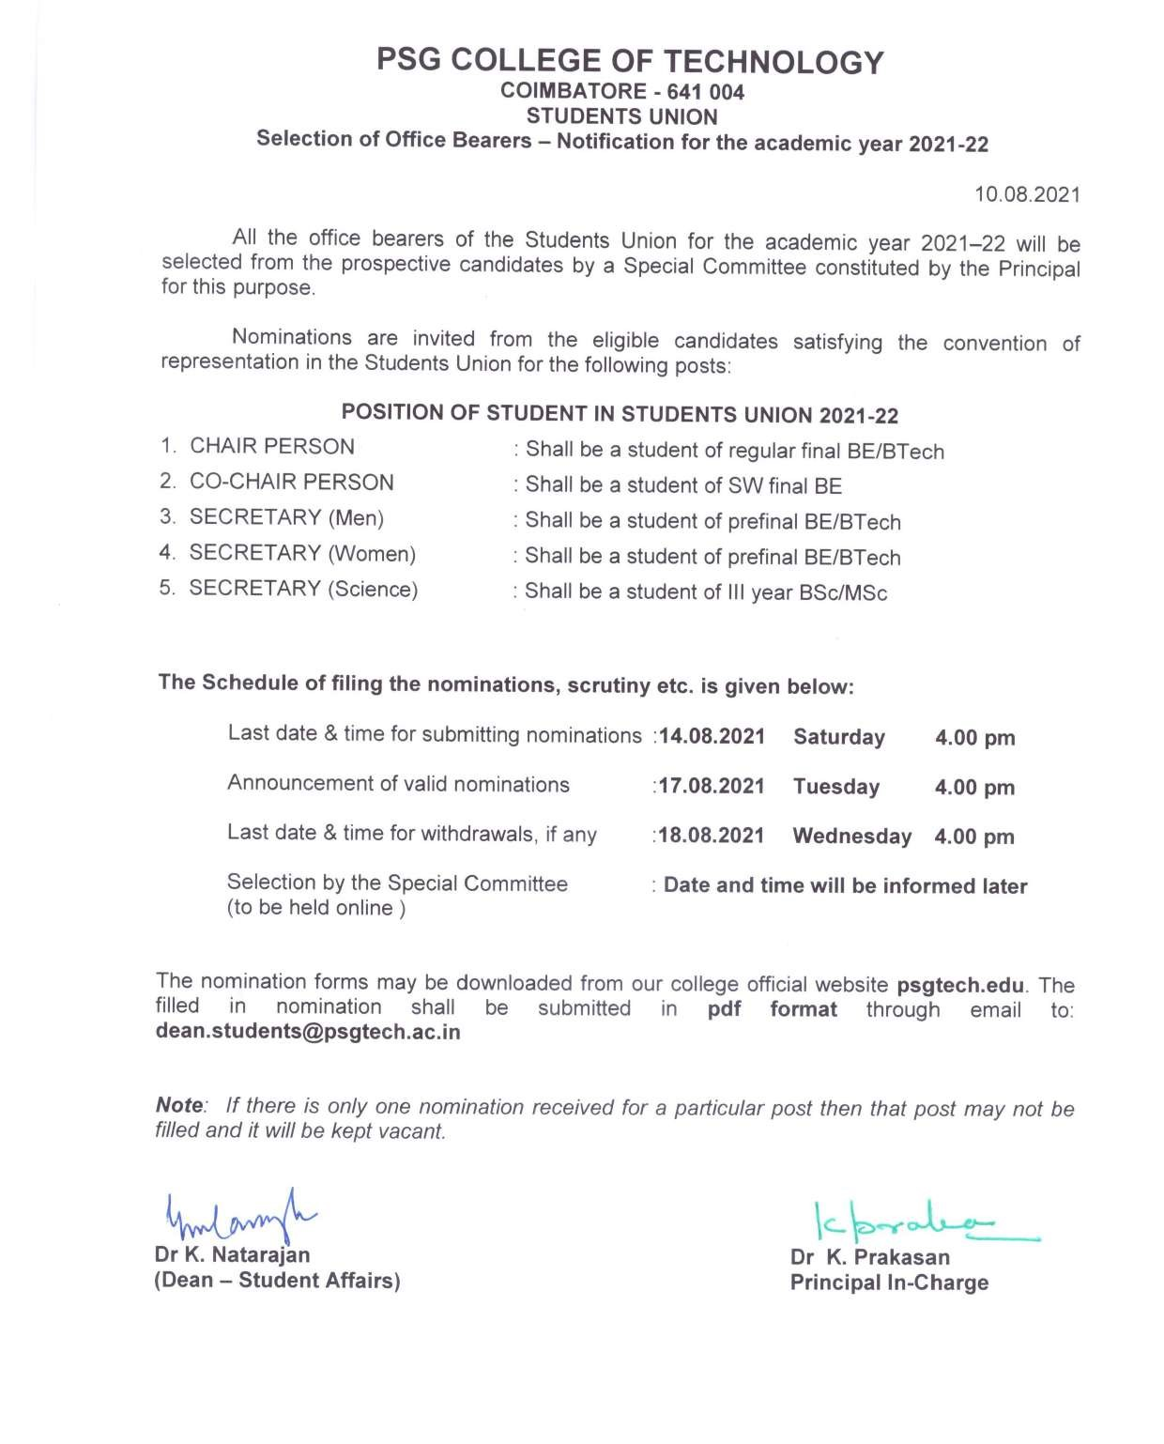

**PSG COLLEGE OF TECHNOLOGY: COIMBATORE**

**STUDENTS UNION 2021-22**

**SELECTION OF OFFICE BEARERS – CANDIDATE’S PARTICULARS**

1. Roll No. & Name : 19Z301 A Kirthic Vishnu

1. Class : B.E. CSE G2 (3rd year)

1. Post Contesting for : Secretary (Men)

1. Previous Standing in the : Core team member in the Students Union(2020-21)

Students union/ other associations Student executive in IETE Student’s Chapter(2020-21)

Executive member of Cisco thingQbator students council (2020-21)

1. Overall percentage of marks / Grade: 9.48

obtained so far

1. Approximate rank in the Class : 10-15

1. Details of the subject & semester Subject Semester No. of attempts

not passed in the first attempt : NIL NIL NIL

1. Warned / stopped for want of

attendance ? If so, give details : NIL NIL NIL

1. Subject to any disciplinary action : NIL NIL NIL

If so, give details

1. Extra curricular activities : Volunteered at Rotary Midtown Dindigul for covid

awareness program during the pandemic. Avid debater

and Carnatic singer. Provided career and future

guidance talks in school.

1. Awards received : NIL
2. Name & Occupation of the parent : C P Arun Kumaar Rane Arun

(Entrepreneur) (Entrepreneur)

1. Address of parent : Office Residence

9-11-16 P.R.R Chinnalapatti,Dindigul 624301.

1. Hostel / Day Scholar : Hostel

1. Any other particulars of importance : School Pupil Leader in a central govt. school.

for consideration (if any) Lead many student teams to victory in said role.

Best outgoing student of the school(2018-19)

The particulars given above are true to the best of my knowledge. I am aware that I will be disqualified if any of the above information is found to be wrong.

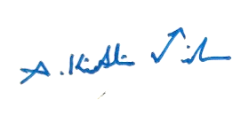

(for students union office use only)

Signature of the student Recommendation of the HOD / Tutor

Date : 13/08/2021 **Page 1/2**

**PSG COLLEGE OF TECHNOLOGY: COIMBATORE**

**STUDENTS UNION 2021-22**

**SELECTION OF OFFICE BEARERS - NOMINATION FORM**

POST FOR WHICH NOMINATION IS FILED : Secretary (Men)

NAME OF THE CANDIDATE : A. Kirthic Vishnu

Roll No: 19Z301 Class : G2 Branch: CSE

Details of Standing in the general council : Member of the publicity team of the

of the Student Union Students Union(2020-21)

Proposed by :

# (The proposer shall send a separate email to dean.students@psgtech.ac.in)

|  |  |  |  |
| --- | --- | --- | --- |
| Roll. No | Name | Class | Contact number |
| 18D211 | Deeksaya . R | BE BIOMEDICAL ENGINEERING  (2018-2022) | 9629450142 |

Seconded by :

# (The seconder shall send a separate email to dean.students@psgtech.ac.in)

|  |  |  |  |
| --- | --- | --- | --- |
| Roll. No | Name | Class | Contact number |
| 18L101 | Abiga Sansuri .M | BE ECE G1(2018-2022) | 94883 70009 |

This nomination is filed in accordance with the constitution of the Student Union and I agree to abide by the committee's rules as stipulated. I am aware that any violation will lead to cancellation of my nomination.

Date : 13-08-2021 Signature of the candidate

# Page 2/2